clown | princess
prince | monster
pirate | ghost
dragon | ladybird
detective | 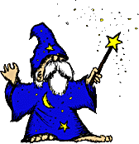  wizard
bird | robot
butterfly | dinosaur
knight | baby
lion | gymnast
cowboy | doctor
alien |   policeman
witch | mermaid
fairy | elephant
robber | donkey
ballerina | astronaut
skeleton | monkey
winged horse | Rudolph
Puss in Boots | frog
jungle | haunted house
space | desert island
park | tower
theme park | forest
sky | street
castle | farm
swimming pool | volcano
Under the sea | beach
desert | mountain
zoo | North Pole
garden | school
party | church
map | hot air balloon
apple | boat
wand | lamp
rucksack | treasure
present | letter
key | boot
ring | helicopter
sword | Ok  book
Magnifying glass | beanstalk
crown | scarecrow
box of chocolates | tightrope
hosepipe | spade
mask | top hat
basket | ball
mask | 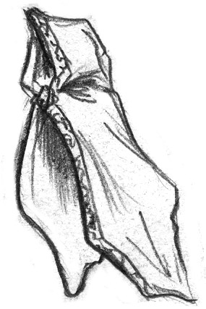  cloak
hat | helmet
torch | torch
drum | trumpet
  pyramid | shell
  diamond | flag
egg | binoculars
night | morning
bedtime | Easter
Autumn | Winter
Christmas | A long, long time ago
Once upon a time | Yesterday
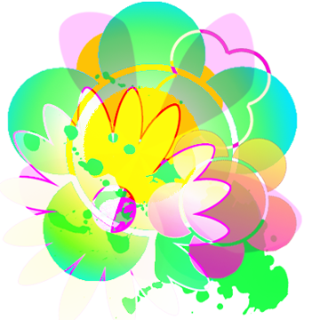  Spring | Summer

